1. **Launch one Linux instance in aws**A screenshot of a computer

   Description automatically generated
2. **Create on file with name Techie_horizonA computer screen with white text

   Description automatically generated**
3. **Copy the file "Techie_Horizon" from aws instance to windows machine.**
4. **Install Jenkins in the server created in step 1**

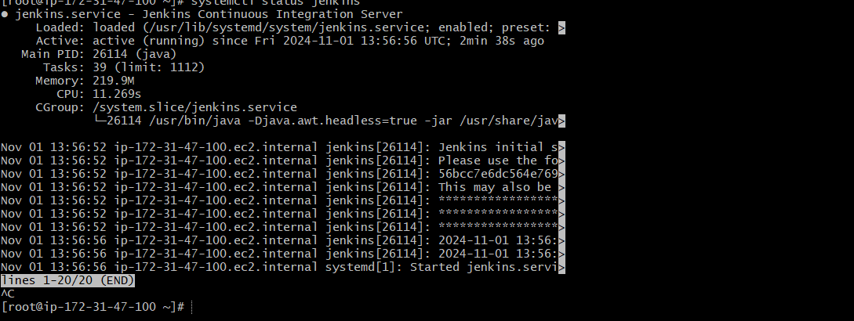

1. **Install httpd,nginx,Apache Tomcat**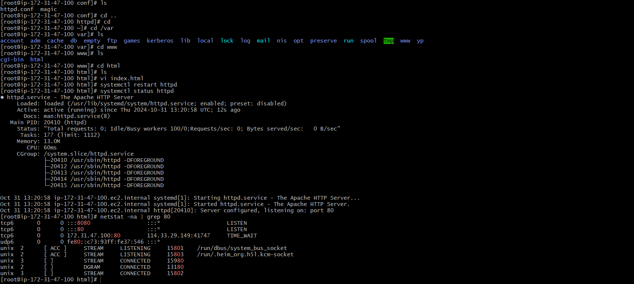A screenshot of a computer

   Description automatically generated**A screenshot of a computer

   Description automatically generated**